Decolonisation and Practice: Project brief and application

Help us to retell the stories of our East Africa collection

The artefacts and photographs in the museum’s East Africa collection were acquired in the early 1900s, while the display and written text have changed very little since the 1920s. Therefore, both reflect the discriminatory beliefs and attitudes of the colonial era. This project will reinterpret and redisplay the East Africa cases, in a way that decentralises the viewpoint of the colonial collector and amplifies the voices of the African communities of origin.

Project dates: June 2022 to May 2023

What will participants do?
The project is in two parts: 1. Redesign and Redisplay and 2. Creation and Celebration.

June to October/November 2022 – Redesign and Redisplay
- Attend 10 fortnightly workshops at the museum, of 1.5 hours. Topics include the ethics of historical photography, research methods, the history and impact of colonialism.
- Work with a variety of people based in the UK and Africa.
- Gain insight into the work and collections of the museum.
- Help to develop a plan for the redisplay and reinterpretation of the East Africa cases, including advising on photographs, artefacts and interpretation text.
- Advise on the retelling and redisplay of the narrative about the ‘Didinga skirmish’.
- Visit and learn from at least one additional museum (to be agreed with participants).
- Contribute to the museum’s blog or other communication channels (optional).
- Be offered 1:1 support to discuss any issues arising from the project.

May 2023 – Creation and Celebration
- You will create your own work inspired by the project and/or artefacts – for example, you might choose to make a podcast or short film, write a poem or a piece of music.
- In May 2023, the new displays will be unveiled at a celebration event attended by our project partners. Your creative piece may form part of this event.

Fees for participants
You will be paid £25 for each workshop attended and £50 for your creative piece.

How and when do I apply?
Complete the application form below.
Email to: lucy.edematie@powell-cottonmuseum.org
Deadline: Friday 3 June 2022 at 5pm

Please see the next page for the application form

This project is kindly supported by Arts Council England National Lottery Project Grants

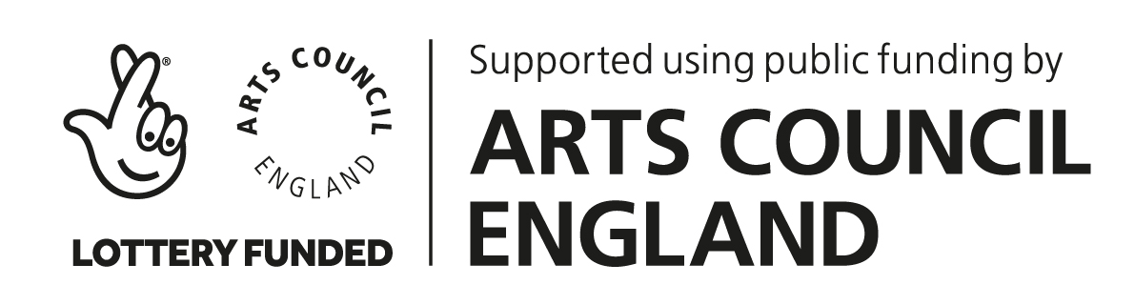

Application form – please type onto this form and return via email

First name: Middle name: Surname:

Please tell us about your current role and summarise your professional experience.
Please tell us why you are applying to work on this co-creation project?
Please tell us why you are the best person for this role – what qualities and skills will you contribute to the project?
What do you hope to achieve by taking part in this project?
Please add any further information that you feel might be relevant.

